Bahria University,

Karachi Campus



COURSE: CSC-110 COMPUTING FUNDAMENTALS

TERM: FALL 2020, CLASS: BSE- 1 (B)

Submitted By:

M Muaz Shahzad 02-131202-081

(Name) (Reg. No.)

Submitted To:

Dr. Salahuddin / Engr. Saniya Sarim

Signed Remarks: Score:

INDEX

|  |  |  |  |  |
| --- | --- | --- | --- | --- |
| SNO | DATE | LAB NO | LAB OBJECTIVE | SIGN |
| 01 |  | 08 | **Bootstrap- Responsive web design** |  |
|  |  |  |  |  |
|  |  |  |  |  |
|  |  |  |  |  |
|  |  |  |  |  |
|  |  |  |  |  |
|  |  |  |  |  |
|  |  |  |  |  |
|  |  |  |  |  |
|  |  |  |  |  |
|  |  |  |  |  |
|  |  |  |  |  |
|  |  |  |  |  |
|  |  |  |  |  |
| SNO | DATE | LAB NO | LAB OBJECTIVE | SIGN |
|  |  |  |  |  |
|  |  |  |  |  |
|  |  |  |  |  |
|  |  |  |  |  |
|  |  |  |  |  |
|  |  |  |  |  |
|  |  |  |  |  |
|  |  |  |  |  |
|  |  |  |  |  |
|  |  |  |  |  |
|  |  |  |  |  |
|  |  |  |  |  |
|  |  |  |  |  |
|  |  |  |  |  |
|  |  |  |  |  |

Bahria University,

Karachi Campus



LAB EXPERIMENT NO.

**8**

LIST OF TASKS

|  |  |
| --- | --- |
| TASK NO | OBJECTIVE |
| 1 | Create the following template using bootstrap use your own content (images, wordings and labels)  <https://ecartstore.000webhostapp.com/Dental/> Pages:  • Home  • Appointments  • Articles  • Contact us  And Simple card of introduction linked with every page |
|  |  |
|  |  |
|  |  |
|  |  |
|  |  |
|  |  |

Submitted On:

Date: 02/12/2020

**Task No. 1: Create the following template using bootstrap use your own content (images, wordings and labels)**

[**https://ecartstore.000webhostapp.com/Dental/**](https://ecartstore.000webhostapp.com/Dental/) **Pages:**

**• Home**

**• Appointments**

**• Articles**

**• Contact us**

**And Simple card of introduction linked with every page**

**Solution:  
HOME:**<!DOCTYPE html>

<meta charset="utf-8">

<meta name="viewport" content="width=device-width, initial-scale=1, shrink-to-fit=no">

<link rel="stylesheet" href="https://cdn.jsdelivr.net/npm/bootstrap@4.5.3/dist/css/bootstrap.min.css" integrity="sha384-TX8t27EcRE3e/ihU7zmQxVncDAy5uIKz4rEkgIXeMed4M0jlfIDPvg6uqKI2xXr2" crossorigin="anonymous">

<title>Dr Human|Home</title>

</head>

<body>

<script src="https://code.jquery.com/jquery-3.5.1.slim.min.js" integrity="sha384-DfXdz2htPH0lsSSs5nCTpuj/zy4C+OGpamoFVy38MVBnE+IbbVYUew+OrCXaRkfj" crossorigin="anonymous"></script>

<script src="https://cdn.jsdelivr.net/npm/bootstrap@4.5.3/dist/js/bootstrap.bundle.min.js" integrity="sha384-ho+j7jyWK8fNQe+A12Hb8AhRq26LrZ/JpcUGGOn+Y7RsweNrtN/tE3MoK7ZeZDyx" crossorigin="anonymous"></script>

<div style="background-color: darkblue"class="headings">

<div style="color: #F1F1F1" class="row">

<div class="col-sm-9" style="padding-left: 100px; padding-top: 40px"><h2>Dr. Zafar</h2></div>

<div class="col-sm-3" style="padding-left: 100px; padding-top: 40px"><h3>0300-0000000</h3></div>

</div>

<div style="color: #F1F1F1" class="row">

<div class="col-sm-9" style="padding-left: 100px;padding-bottom: 30px"><h4>Dentist</h4></div>

<div class="col-sm-3" style="padding-left: 100px;padding-bottom: 30px"><h4>Phone Number</h4></div>

</div>

</div>

<nav class="navbar navbar-expand-lg navbar-light bg-dark">

<a style="padding-left: 130px;"class="navbar-brand" href="#">Dr. Zafar</a>

<button class="navbar-toggler" type="button" data-toggle="collapse" data-target="#navbarSupportedContent" aria-controls="navbarSupportedContent" aria-expanded="false" aria-label="Toggle navigation">

<span class="navbar-toggler-icon"></span>

</button>

<div class="collapse navbar-collapse" id="navbarNav">

<ul class="navbar-nav">

<li style="padding-left: 5px;padding-right: 10px;font-size: 20px" class="nav-item active">

<a class="nav-link" href="bootstrap.html#">Home<span class="sr-only">(current)</span></a>

</li>

<li style="padding-left: 5px;padding-right: 10px;font-size: 20px" class="nav-item">

<a class="nav-link" href="appointment.html#">Appointments</a>

</li>

<li style="padding-left: 5px;padding-right: 10px;font-size: 20px" class="nav-item">

<a class="nav-link" href="articles.html#">Articles</a>

</li>

<li style="padding-left: 5px;padding-right: 10px;font-size: 20px" class="nav-item">

<a class="nav-link" href="Contacus.html#">Contact Us</a>

</li>

</ul>

</div>

</nav>

</div>

<div style="" class="row">

<div style="padding-top: 15px; padding-right: 20px;padding-left: 200px;padding-bottom: 15px" class="col-sm-8 offset-sm-0"><div class="card" >

<div style="background-color: lightyellow" class="card-body">

<h4 style="color: blue;font-size: 230%;font-family: Timesnewroman" class="card-title">Welcome To Online Clinic</h4>

<hr>

<br><p style="padding-bottom: 100px;font-size: 15px" class="card-text">Lorem ipsum dolor sit amet, consectetur adipisicing elit, sed do eiusmod tempor incididunt ut labore et dolore magna aliqua. Ut enim ad minim veniam, quis nostrud exercitation ullamco laboris nisi ut aliquip ex ea commodo consequat. Duis aute irure dolor in reprehenderit in voluptate velit esse cillum dolore eu fugiat nulla pariatur. Excepteur sint occaecat cupidatat non proident, sunt in culpa qui officia deserunt mollit anim id est laborum.</p>

<div class="row">

<div class="col-sm-1"></div>

<h5 style="color: green;text-align: left;padding-left:60px;;font-size: 35px;font-family: Timesnewroman"class="card-text">Meet the Doctor</h5></div>

<hr><img src="E:\CF LAB\doctor.png" style="width: 150px;height: 130px">

<p style="padding-left: 105px;padding-bottom: 100px;font-size: 15px">Lorem ipsum dolor sit amet, consectetur adipisicing elit, sed do eiusmod tempor incididunt ut labore et dolore magna aliqua. Ut enim ad minim veniam, quis nostrud exercitation ullamco laboris nisi ut aliquip ex ea commodo consequat. Duis aute irure dolor in reprehenderit in voluptate velit esse cillum dolore eu fugiat nulla pariatur. Excepteur sint occaecat cupidatat non proident, sunt in culpa qui officia deserunt mollit anim id est laborum.</p>

<h5 style="color: #FFA500;font-family: Timesnewroman;font-size: 35px"class="card-title">Why Choose Us</h5>

<hr>

<br><p>Lorem ipsum dolor sit amet, consectetur adipisicing elit, sed do eiusmod tempor incididunt ut labore et dolore magna aliqua. Ut enim ad minim veniam, quis nostrud exercitation ullamco laboris nisi ut aliquip ex ea commodo consequat. Duis aute irure dolor in reprehenderit in voluptate velit esse cillum dolore eu fugiat nulla pariatur. Excepteur sint occaecat cupidatat non proident, sunt in culpa qui officia deserunt mollit anim id est laborum.</p>

</div>

</div></div>

<div class="col-sm-4" >

<div style="padding-left: 10px !important;padding-top: 15px;" class="col-sm-3"><div class="card" style="display:inline-block;" >

<div style="background-color: lightyellow" class="card-body">

<h4 style="color: #FFA500;font-size: 80;font-family: Timesnewroman" class="card-title">Welcome</h4>

<hr>

<div style="padding-top:20px" class="col-sm-12">

<div class="card-body">

<button style="width: 100%;font-size: 20px;font-family: Timesnewroman" type="button" class="btn btn-success">Contact</button><br><br>

<button style="width: 100%;font-size: 20px;font-family: Timesnewroman" type="button" class="btn btn-danger"><img style="width: 10%;height: 10%;padding-right: 5px;padding-bottom: 2px;" img src="C:\Users\Muaaz Shahzad\Downloads\pngkey.com-email-icon-white-png-9311379.png"></span>Email</button><br><br><br>

<hr>

<h4 style="color: green;padding-top:120px;font-size: 35px;font-family: Timesnewroman; "class="card-title">Visit Us</h4><div class="mapouter"><div class="gmap_canvas"><iframe width="277" height="422" id="gmap_canvas" src="https://maps.google.com/maps?q=Majeed%20SRE%20Dalmian%20Stadium%20Road%20KArachi%20Pakistan&t=&z=13&ie=UTF8&iwloc=&output=embed" frameborder="0" scrolling="no" marginheight="0" marginwidth="0"></iframe> <a href='https://www.symptoma.com/en/info/covid-19'>New Coronavirus</a> <script type='text/javascript' src='https://maps-generator.com/google-maps-authorization/script.js?id=455e4efc8304b731eae6b2a67c815e80ab2b0d0f'></script><br><br>

</div></div></div></div></div>

</div></div>

</div>

<footer style="background-color: #223344;align-items: baseline; position: static; ;bottom: 0;width: 100%;padding-bottom: 40px;padding-top: 40px" class="footer">

<div style="color: #F1F1F1;" class="footer-copyright text-center py-3">©️ All Rights Reserved

<a style="color: #FFA500" href="bootstrap.html#">Dr Zafar</a>

</div>

</footer>

</body>

</html>

**APPOINTMENTS:**<!DOCTYPE html>

<meta charset="utf-8">

<meta name="viewport" content="width=device-width, initial-scale=1, shrink-to-fit=no">

<link rel="stylesheet" href="https://cdn.jsdelivr.net/npm/bootstrap@4.5.3/dist/css/bootstrap.min.css" integrity="sha384-TX8t27EcRE3e/ihU7zmQxVncDAy5uIKz4rEkgIXeMed4M0jlfIDPvg6uqKI2xXr2" crossorigin="anonymous">

<title>Dr Human|Appointments</title>

</head>

<body>

<script src="https://code.jquery.com/jquery-3.5.1.slim.min.js" integrity="sha384-DfXdz2htPH0lsSSs5nCTpuj/zy4C+OGpamoFVy38MVBnE+IbbVYUew+OrCXaRkfj" crossorigin="anonymous"></script>

<script src="https://cdn.jsdelivr.net/npm/bootstrap@4.5.3/dist/js/bootstrap.bundle.min.js" integrity="sha384-ho+j7jyWK8fNQe+A12Hb8AhRq26LrZ/JpcUGGOn+Y7RsweNrtN/tE3MoK7ZeZDyx" crossorigin="anonymous"></script>

<div style="background-color: darkblue"class="headings">

<div style="color: #F1F1F1" class="row">

<div class="col-sm-9" style="padding-left: 100px; padding-top: 40px"><h2>Dr. Zafar</h2></div>

<div class="col-sm-3" style="padding-left: 100px; padding-top: 40px"><h3>0300-0000000</h3></div>

</div>

<div style="color: #F1F1F1" class="row">

<div class="col-sm-9" style="padding-left: 100px;padding-bottom: 30px"><h4>Dentist</h4></div>

<div class="col-sm-3" style="padding-left: 100px;padding-bottom: 30px"><h4>Phone Number</h4></div>

</div>

</div>

<nav class="navbar navbar-expand-lg navbar-light bg-dark">

<a style="padding-left: 130px;"class="navbar-brand" href="#">Dr. Zafar</a>

<button class="navbar-toggler" type="button" data-toggle="collapse" data-target="#navbarSupportedContent" aria-controls="navbarSupportedContent" aria-expanded="false" aria-label="Toggle navigation">

<span class="navbar-toggler-icon"></span>

</button>

<div class="collapse navbar-collapse" id="navbarNav">

<ul class="navbar-nav">

<li style="padding-left: 5px;padding-right: 10px;font-size: 20px" class="nav-item active">

<a class="nav-link" href="bootstrap.html#">Home<span class="sr-only">(current)</span></a>

</li>

<li style="padding-left: 5px;padding-right: 10px;font-size: 20px" class="nav-item">

<a class="nav-link" href="appointment.html#">Appointments</a>

</li>

<li style="padding-left: 5px;padding-right: 10px;font-size: 20px" class="nav-item">

<a class="nav-link" href="articles.html#">Articles</a>

</li>

<li style="padding-left: 5px;padding-right: 10px;font-size: 20px" class="nav-item">

<a class="nav-link" href="contacus.html#">Contact Us</a>

</li>

</ul>

</div>

</nav>

</div>

<div style="" class="row">

<div style="padding-top: 50px;padding-left: 50px" class="col-md-12 offset-md-2"><div class="card" style="width: 60%;">

<div style="background-color: lightyellow" class="card-body">

<h3 style="color: orange;text-align: center;font-size: 35px;font-family: Timesnewroman;"class="card-title">Meet the Doctor</h3>

<hr>

<img style="width: 30%;height: 70%;float: left;" src="E:\CF LAB\doctor.png" style="width: 150px;height: 130px"><br><p style="text-align: justify;">Lorem ipsum dolor sit amet, consectetur adipisicing elit, sed do eiusmod tempor incididunt ut labore et dolore magna aliqua. Ut enim ad minim veniam, quis nostrud exercitation ullamco laboris nisi ut aliquip ex ea commodo consequat. Duis aute irure dolor in reprehenderit in voluptate velit esse cillum dolore eu fugiat nulla pariatur. Excepteur sint occaecat cupidatat non proident, sunt in culpa qui officia deserunt mollit anim id est laborum.</p>

</div>

</div></div>

<footer style="background-color: #223344;align-items: baseline; position: absolute;bottom: 0;width: 100%;padding-bottom: 10px;padding-top: 10px" class="footer">

<div style="color: #F1F1F1;" class="footer-copyright text-center py-3">©️ All Rights Reserved

<a style="color: #FFA500" href="bootstrap.html#">Dr Zafar</a>

</div>

</footer>

</body>

</html> **ARTICLES:**<!DOCTYPE html>

<meta charset="utf-8">

<meta name="viewport" content="width=device-width, initial-scale=1, shrink-to-fit=no">

<link rel="stylesheet" href="https://cdn.jsdelivr.net/npm/bootstrap@4.5.3/dist/css/bootstrap.min.css" integrity="sha384-TX8t27EcRE3e/ihU7zmQxVncDAy5uIKz4rEkgIXeMed4M0jlfIDPvg6uqKI2xXr2" crossorigin="anonymous">

<title>Dr Human|Articles</title>

</head>

<body>

<script src="https://code.jquery.com/jquery-3.5.1.slim.min.js" integrity="sha384-DfXdz2htPH0lsSSs5nCTpuj/zy4C+OGpamoFVy38MVBnE+IbbVYUew+OrCXaRkfj" crossorigin="anonymous"></script>

<script src="https://cdn.jsdelivr.net/npm/bootstrap@4.5.3/dist/js/bootstrap.bundle.min.js" integrity="sha384-ho+j7jyWK8fNQe+A12Hb8AhRq26LrZ/JpcUGGOn+Y7RsweNrtN/tE3MoK7ZeZDyx" crossorigin="anonymous"></script>

<div style="background-color: darkblue"class="headings">

<div style="color: #F1F1F1" class="row">

<div class="col-sm-9" style="padding-left: 100px; padding-top: 40px"><h2>Dr. Zafar</h2></div>

<div class="col-sm-3" style="padding-left: 100px; padding-top: 40px"><h3>0300-0000000</h3></div>

</div>

<div style="color: #F1F1F1" class="row">

<div class="col-sm-9" style="padding-left: 100px;padding-bottom: 30px"><h4>Dentist</h4></div>

<div class="col-sm-3" style="padding-left: 100px;padding-bottom: 30px"><h4>Phone Number</h4></div>

</div>

</div>

<nav class="navbar navbar-expand-lg navbar-light bg-dark">

<a style="padding-left: 130px;"class="navbar-brand" href="#">Dr. Zafar</a>

<button class="navbar-toggler" type="button" data-toggle="collapse" data-target="#navbarSupportedContent" aria-controls="navbarSupportedContent" aria-expanded="false" aria-label="Toggle navigation">

<span class="navbar-toggler-icon"></span>

</button>

<div class="collapse navbar-collapse" id="navbarNav">

<ul class="navbar-nav">

<li style="padding-left: 5px;padding-right: 10px;font-size: 20px" class="nav-item active">

<a class="nav-link" href="bootstrap.html#">Home<span class="sr-only">(current)</span></a>

</li>

<li style="padding-left: 5px;padding-right: 10px;font-size: 20px" class="nav-item">

<a class="nav-link" href="appointment.html#">Appointments</a>

</li>

<li style="padding-left: 5px;padding-right: 10px;font-size: 20px" class="nav-item">

<a class="nav-link" href="articles.html#">Articles</a>

</li>

<li style="padding-left: 5px;padding-right: 10px;font-size: 20px" class="nav-item">

<a class="nav-link" href="Contacus.html#">Contact Us</a>

</li>

</ul>

</div>

</nav>

</div>

<div style="" class="row">

<div style="padding-top: 50px;padding-left: 50px" class="col-md-9 offset-md-3"><div class="card" style="width: 60%;">

<div class="card-body">

<p style="text-align: center;font-size: 35px;font-family: Timesnewroman; color: orange;">No Articles Found!</p>

</div>

</div></div></div>

<footer style="background-color: #223344;align-items: baseline; position: absolute;bottom: 0;width: 100%;" class="footer">

<div style="color: #F1F1F1;" class="footer-copyright text-center py-3">©️ All Rights Reserved

<a style="color: #FFA500" href="bootstrap.html#">Dr Zafar</a>

</div>

</footer>

</body>

</html> **CONTACT US:**<!DOCTYPE html>

<meta charset="utf-8">

<meta name="viewport" content="width=device-width, initial-scale=1, shrink-to-fit=no">

<link rel="stylesheet" href="https://cdn.jsdelivr.net/npm/bootstrap@4.5.3/dist/css/bootstrap.min.css" integrity="sha384-TX8t27EcRE3e/ihU7zmQxVncDAy5uIKz4rEkgIXeMed4M0jlfIDPvg6uqKI2xXr2" crossorigin="anonymous">

<title>Dr Human|Contact Us</title>

</head>

<body>

<script src="https://code.jquery.com/jquery-3.5.1.slim.min.js" integrity="sha384-DfXdz2htPH0lsSSs5nCTpuj/zy4C+OGpamoFVy38MVBnE+IbbVYUew+OrCXaRkfj" crossorigin="anonymous"></script>

<script src="https://cdn.jsdelivr.net/npm/bootstrap@4.5.3/dist/js/bootstrap.bundle.min.js" integrity="sha384-ho+j7jyWK8fNQe+A12Hb8AhRq26LrZ/JpcUGGOn+Y7RsweNrtN/tE3MoK7ZeZDyx" crossorigin="anonymous"></script>

<div style="background-color: darkblue"class="headings">

<div style="color: #F1F1F1" class="row">

<div class="col-sm-9" style="padding-left: 100px; padding-top: 40px"><h2>Dr. Zafar</h2></div>

<div class="col-sm-3" style="padding-left: 100px; padding-top: 40px"><h3>0300-0000000</h3></div>

</div>

<div style="color: #F1F1F1" class="row">

<div class="col-sm-9" style="padding-left: 100px;padding-bottom: 30px"><h4>Dentist</h4></div>

<div class="col-sm-3" style="padding-left: 100px;padding-bottom: 30px"><h4>Phone Number</h4></div>

</div>

</div>

<nav class="navbar navbar-expand-lg navbar-light bg-dark">

<a style="padding-left: 130px;"class="navbar-brand" href="#">Dr. Zafar</a>

<button class="navbar-toggler" type="button" data-toggle="collapse" data-target="#navbarSupportedContent" aria-controls="navbarSupportedContent" aria-expanded="false" aria-label="Toggle navigation">

<span class="navbar-toggler-icon"></span>

</button>

<div class="collapse navbar-collapse" id="navbarNav">

<ul class="navbar-nav">

<li style="padding-left: 5px;padding-right: 10px;font-size: 20px" class="nav-item active">

<a class="nav-link" href="bootstrap.html#">Home<span class="sr-only">(current)</span></a>

</li>

<li style="padding-left: 5px;padding-right: 10px;font-size: 20px" class="nav-item">

<a class="nav-link" href="appointment.html#">Appointments</a>

</li>

<li style="padding-left: 5px;padding-right: 10px;font-size: 20px" class="nav-item">

<a class="nav-link" href="articles.html#">Articles</a>

</li>

<li style="padding-left: 5px;padding-right: 10px;font-size: 20px" class="nav-item">

<a class="nav-link" href="contacus.html#">Contact Us</a>

</li>

</ul>

</div>

</nav>

</div>

<div style="align-items: center" class="row">

<div style="padding-top: 40px;padding-left: 50px" class="col-md-9 offset-md-3"><div class="card" style="width: 60%;">

<div style="background-color: lightyellow" class="card-body">

<h3 style="color: green;text-align: center;font-size: 35px;font-family: Timesnewroman;"class="card-title">Contact Form</h3><br>

<hr>

<form id="contactfrom" style="margin-top: 20px">

<center><label style="font-size: 14px;color: green;font-family: Timesnewroman;font-size: 23px">Full Name</label><br></center>

<input style="width: 100%" type="textbox" name="name" placeholder="eg: M Muaz"></input><br>

<center> <label style="font-size: 14px;color: green;font-family: Timesnewroman;font-size: 23px">Password</label><br></center>

<input style="width: 100%"type="password" name="password" placeholder="12345"><br>

<center> <label style="font-size: 14px;color: green;font-family: Timesnewroman;font-size: 23px">Your Queries</label><br></center>

<input style="width: 100%;"type="textarea" name="queries" placeholder="abcd..."><br>

<br>

<button style="margin-left:255px;opacity: 90%;font-family: Timesnewroman;font-size: 23px;" type="submit" class="btn btn-success">Submit</button>

</form>

</div>

</div>

</div></div>

<footer style="background-color: #223344;align-items: baseline; position: absolute;bottom: 0;width: 100%;" class="footer">

<div style="color: #F1F1F1;" class="footer-copyright text-center py-3">©️ All Rights Reserved

<a style="color: #FFA500" href="bootstrap.html#">Dr Zafar</a>

</div>

</footer>

</body>

</html>

**Output:  
  
HOME: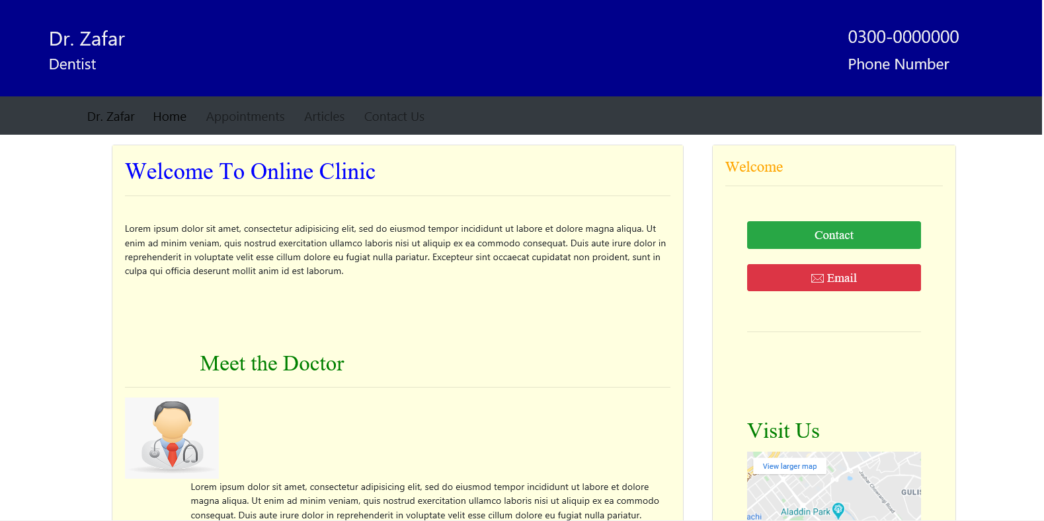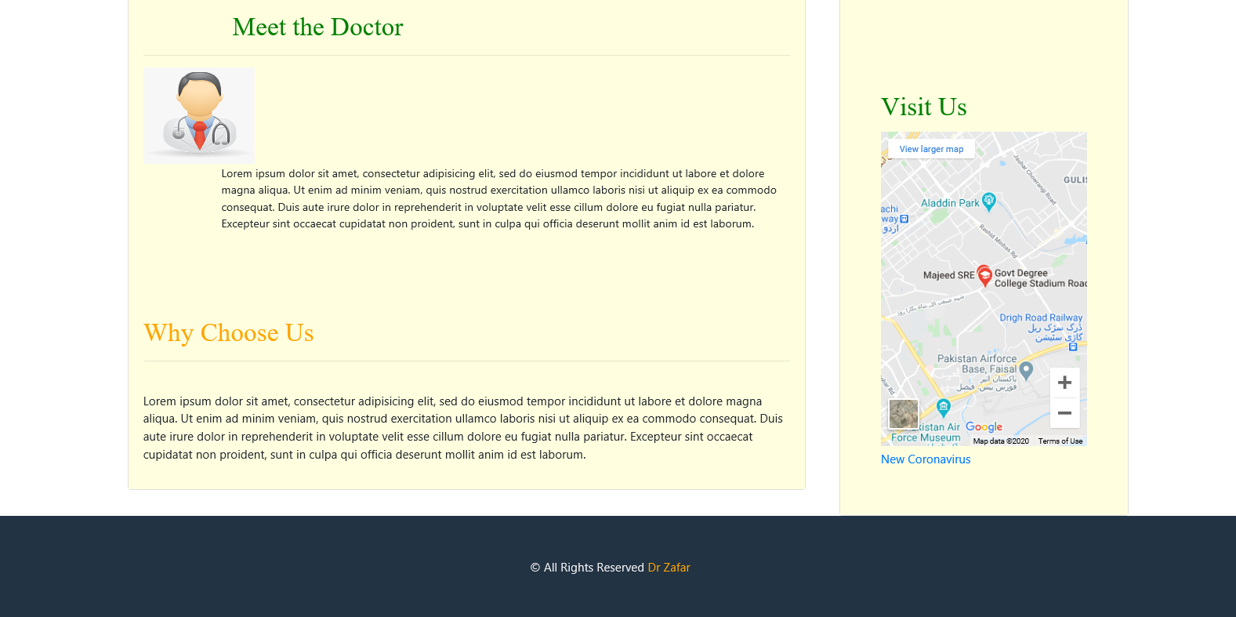 APPOINMENTS: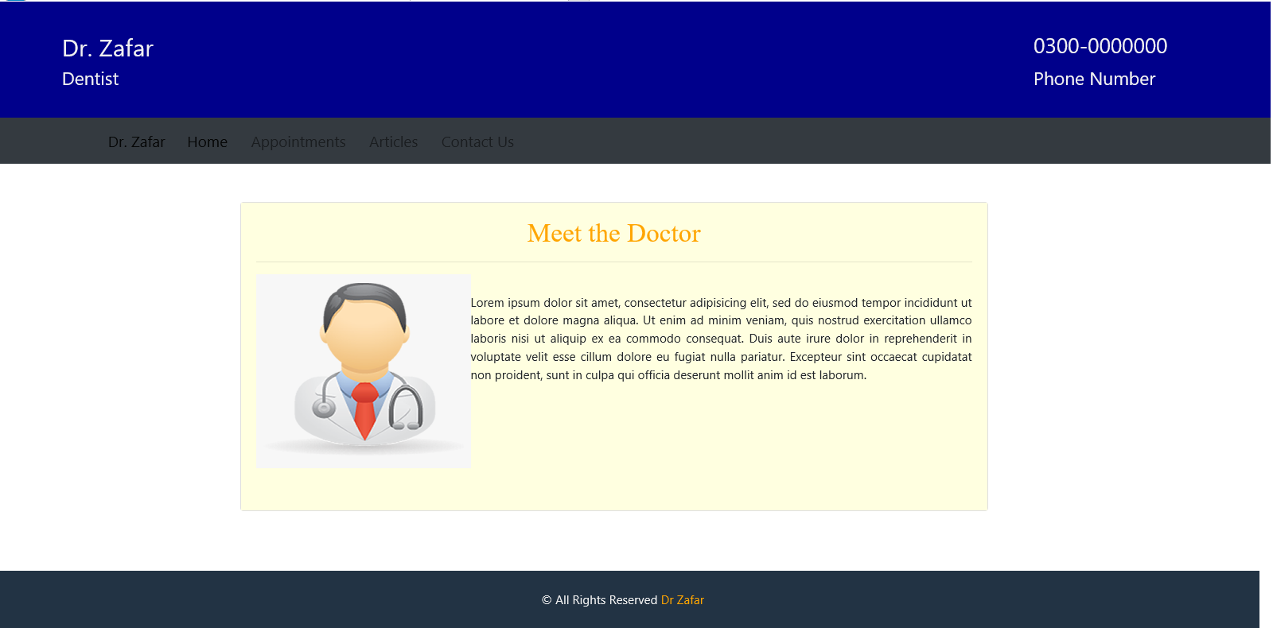 ARTICLES: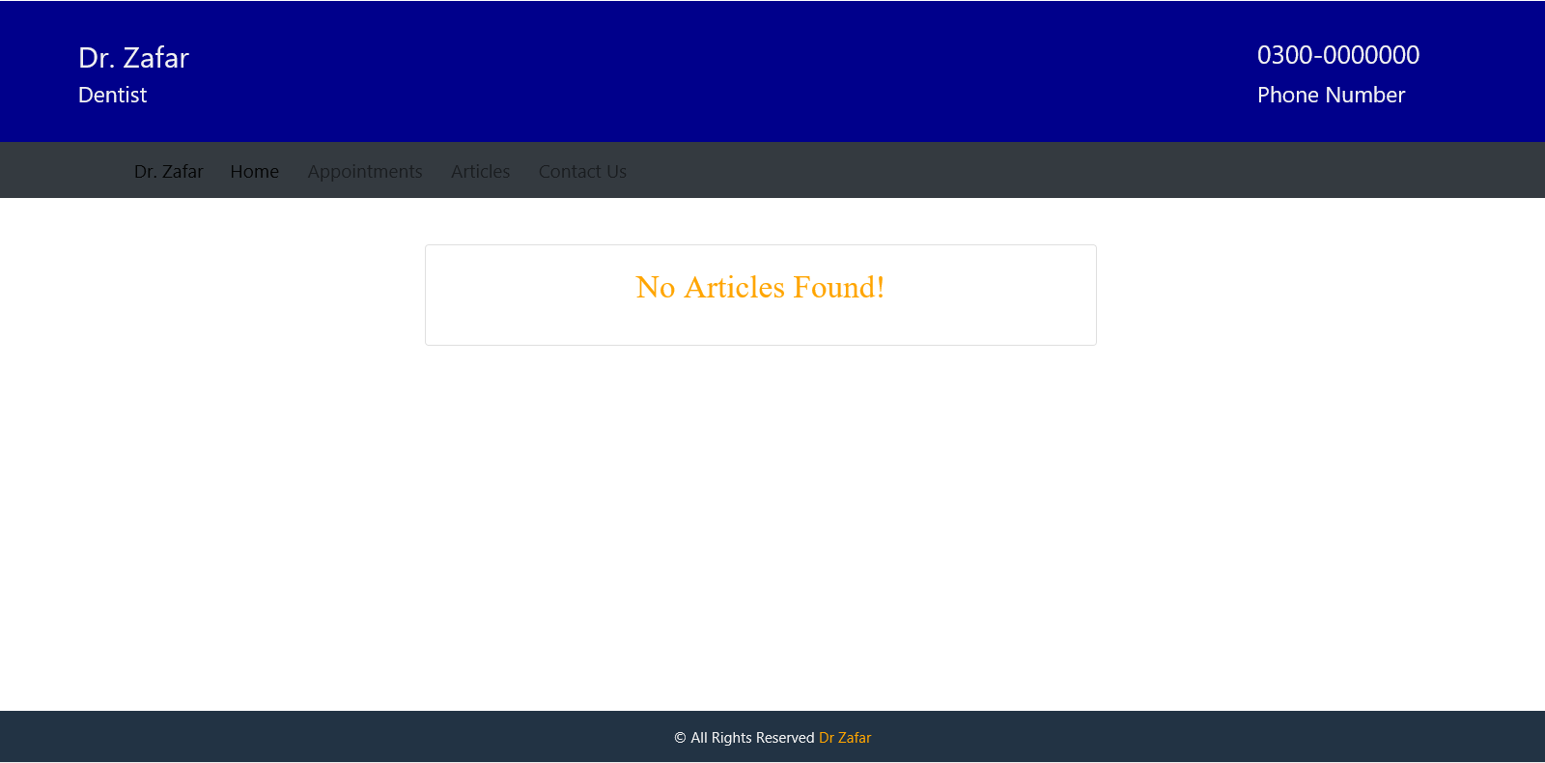 CONTACT US:**